

Draw It or Lose It

CS 230 Project Software Design Document
Version 3.0

Table of Contents

CS 230 Project Software Design Template 1
Table of Contents 2
Document Revision History 2
Executive Summary 3
Requirements 3
Design Constraints 3
System Architecture View 3
Domain Model 3
Evaluation 4
Recommendations 5

Document Revision History

Version | Date | Author | Comments
1.0 | 09/26/2026 | Nick Scott | Executive Summary, Requirements, Design Constraints, and Domain Model sections added for “Draw It or Lose It” web-application.
2.0 | 10/11/2026 | Nick Scott | Evaluation for different operating systems, exploring both server-side and client-side development.
3.0 | 10/25/2026 | Nick Scott | Recommendations for operating system, storage and memory management, and security for the application.

Executive Summary

Creative Technology Solution’s new client, The Gaming Room, has created an Android-only app called “Draw It or Lose It” in which members across multiple teams view various stock images in order to guess the answer to a puzzle (such as a phrase or object). If the current team fails to guess the correct answer within 30 seconds, the remaining teams will have 15 seconds each to try to solve the puzzle with one guess. The Gaming Room would like to develop a web-based version of this game, so that it can be played across multiple platforms.

In Draw It or Lose It, there will be one or more teams, with each time having multiple team members assigned to it. Only one game service instance will be active at once, and each game, team, and member name must be unique.

Requirements

Technical Requirements
- Draw It or Lose It offered through any modern web browser, such as Google Chrome, Firefox, Safari, Microsoft Edge, etc.
- A modern web browser requires an operating system that can access the internet and download a web browser.

Software Requirements
- Allows to have multiple teams with unique names
- Team members with unique names will be assigned to a single team
- Only one Game Service Instance active at once
- Game objects are tracked within the Game Service Instance with unique identifiers

Business Requirements
- Stay within The Gaming Room’s given budget
- Expand Draw It or Lose It’s player base

Design Constraints

- Draw It or Lose It must work across multiple types of web browsers. The same functionality should be expected regardless of the exact browser used to access the application, as long as the user is connected to the internet.
- There is an existing version of Draw It or Lose It offered as an Android app. Players can expect to play the same game on the web version as the mobile version. Cross-play is an added bonus for extra unity.
- A server-client structure will need to be built, so that multiple players across different devices can all connect to the same Game Instance, and view the same information synchronously. If timers, pictures, or guesses are desynced, then the game will be unfair or unplayable.
- A database is required to store stock photos, puzzle answers, as well as all other infrastructure information such as unique Games, Teams, and Players.
- The codebase should be mostly compatible with any existing codebase for Draw It or Lose It. Given that Android applications use Java for development, the web-based version should seek a similar path.
- The system must be built within The Gaming Room’s schedule and budget.

System Architecture View

Please note: There is nothing required here for these projects, but this section serves as a reminder that describing the system and subsystem architecture present in the application, including physical components or tiers, may be required for other projects. A logical topology of the communication and storage aspects is also necessary to understand the overall architecture and should be provided.

Domain Model

The UML Class Diagram for Draw It or Lose It is outlined below, and is implemented as so:
- The ProgramDriver contains the main method, which will drive the program and initiate the bulk of the Draw It or Lose It code, such as storing the information for the current GameService.
- ProgramDriver is directly associated with the SingletonTester, which is used to test the singleton pattern described in the next bullet point.
- The GameService class is used to store all Game instances, of which there may be 0 or more, as well as future IDs to be used when instantiating a given Entity. The GameService class follows the singleton pattern, which means only one GameService should exist at once. Any and all references to a GameService object should refer to the same instance in memory. The system should block any attempt to create an additional GameService object.
- The Entity class is a generic class with an ID and name. It will be important to track these attributes so that future Entity objects are unique. The Entity class is meant to be extended by the Game, Team, and Player classes, all of which need to have unique identifiers in the system.
- The Game class is used to store the teams for that given Game instance. There may be 0 or more Team objects. The Game class is guaranteed to have a unique identifier due to its inheritance from Entity.
- The Team class is used to store the players for that given Team instance. There may be 0 or more Player objects. The Team class is guaranteed to have a unique identifier due to its inheritance from Entity.
- The Player class represents a user playing the game. The Player class is guaranteed to have a unique identifier due to its inheritance from Entity.

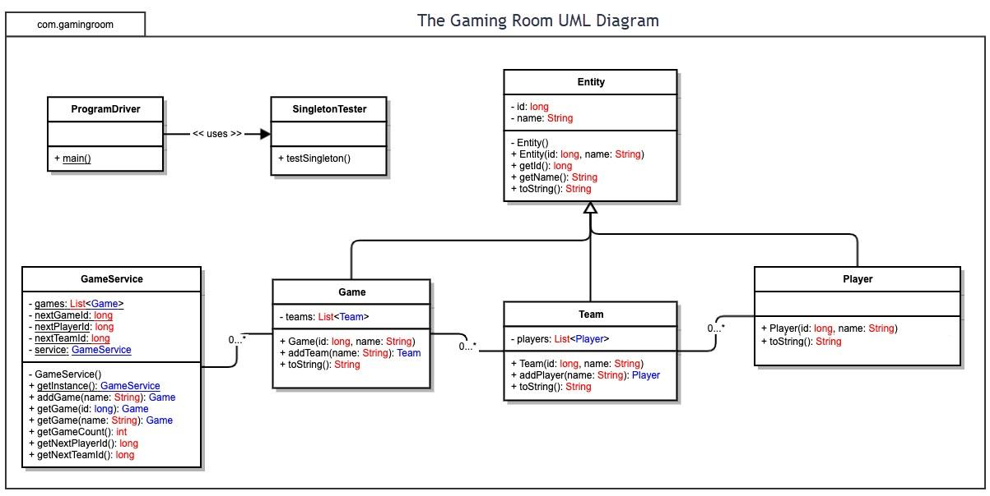

Evaluation

Development Requirements | Mac | Linux | Windows | Mobile Devices
Server Side | Apple offers a server hosting software known as Mac OS X Server. However, as of April 21, 2022, Apple has ended support for this software. Modern macOS cannot run this software, meaning we would need to use an older version of macOS like macOS Monterey, which would come with its own security flaws with using an outdated operating system. Primitive server features, like file sharing, remain included in new versions of macOS, but overall, would be a poor choice if we wanted additional features aside from file sharing or additional scalability. | Linux is the top choice for server hosting, thanks to its open-source and license-free nature, making it low cost. Linux is highly regarded for its high security as it offers many controls for the developer, as well as receiving frequent patches to address the latest security concerns. Compared to other operating systems, Linux uses less resources making it easily scalable to handle high traffic and heavy loads. Linux’s flexibility means developers have many tools at their disposal to customize the server to their exact needs. | Windows server hosting is catered by Microsoft to offer an easier way for developers to jump into server hosting, as it features a graphical interface, as opposed to working with a command line. It is the only way to interact with Windows-specific software, such as the .NET framework. License fees are high. For Microsoft Server 2025, the Standard edition starts at $1,176, scaling up to $6,771 for even larger servers. Windows Servers do receive security patches but its mandatory fashion makes server downtime more frequent. | Because of mobile devices’ limited hardware capabilities due to their portability, server hosting would be limited to lightweight software. There are not many services offered for server hosting, although definitely not impossible. After all, Android is an operating system that is open-source and runs on a modified Linux kernel. It would take extra work on the developer’s end to make sure the server is up to the latest security vulnerabilities. Scalability would be an issue for mobile device server hosting with its limited capabilities. Additionally, mobile devices are battery-powered, meaning the phone would either need to be consistently charging (which would be bad for its battery), or major downtime between charges.
Client Side | Native macOS applications need to be developed through Xcode, which only runs on a Mac machine. While Xcode is free to use, publishing apps through the App Store requires a license which runs at $99/year. More specialized expertise is needed as Swift is used as the programming language.  Web-based clients is a matter of making a web frontend, such as through HTML, CSS, and JavaScript, and is a common approach for developers, as well as flexibility in the IDE used. As long as the device can connect to the internet and use an internet browser, clients can connect.  Mac OS and OS X represent about 6.5% of the worldwide market share together. While not negligible, it does represent a small percentage of users. | Development is extremely flexible on the Linux operating system, open to all different types of programming languages such as Python, C/C++, and Java. Making a native application or web-based frontend for users should not prove to be an issue, as there are many options available for developers to take advantage of.  However, Linux users represent an incredibly small share of users in the worldwide market, about 1.7%. Putting in the effort to develop a native app for Linux may prove fruitless as it would not increase the client-base all that much. A frontend through a web browser would be more recommended. | Windows offers many tools for developers to make a client-side application natively. One popular example is Visual Studio, which uses .NET and C# for its applications, which are popular choices in development. Visual Studio offers multiple levels of licenses, starting with free, to $100/month, up to $500/month. Different licenses give availability to a suite of Microsoft tools. For example, Azure DevOps give pipelines to design, test, build, and deploy applications.  As discussed in other operating systems, web based frontend development is a popular option.  Windows holds a 29% market share, which is a considerable amount of users. | Client-side development will differ based on the specific operating system.  Development for Android is through the Android Studio IDE, which uses the Kotlin programming language. There are lots of helpful libraries which would help a developer throughout the process. Android is the most popular operating system, let alone for mobile devices. Their market share is 42.7%, which is the majority of users internationally.  For iOS, Xcode uses the Swift programming language to develop its software. Publishing a native app would run at $99/year. iOS users represent 19.37% of the global market share.  As discussed in other operating systems, web based frontend development is a popular option.
Development Tools | Xcode is required for Mac development, which uses the Swift and SwiftUI programming language.  Objective-C is used for legacy Mac systems, which is meant to be replaced by Swift.  Publishing apps through the App Store requires a license which runs at $99/year.  Web-based development is flexible in terms of IDE used and programming languages. | Linux primarily uses C/C++ for native development, although other alternatives like Rust, Go, and Python exist.  IDEs are versatile and up to developer’s choice. Popular choices include Visual Studio Code or the JetBrains suite (like CLion, PyCharm, and GoLand).  Linux has plenty of free and open-source tools for the developer.  Web-based development is flexible in terms of IDE used and programming languages. | Visual Studio is a popular choice for Windows development, although there are many other options available based on preference. For example, the JetBrains suite is also offered which is a popular alternative.  C# and the .NET framework are the main languages used for native Windows applications.  Visual Studio offers multiple levels of licenses, starting with free, to $100/month, up to $500/month, per developer, making development costly based on the team size.  Web-based development is flexible in terms of IDE used and programming languages. | For Android, Android Studio is the main IDE used to develop applications, alongside the programming language Kotlin, an open-source programming language meant to run seamlessly with Java.  Publishing an Android app on the Google Play store requires a one-time $25 fee.  iOS uses Xcode, Swift, and SwiftUI, just like Mac development.  Publishing apps through the App Store requires a license which runs at $99/year.  Web-based development is flexible in terms of IDE used and programming languages.

Recommendations

Analyze the characteristics of and techniques specific to various systems architectures and make a recommendation to The Gaming Room. Specifically, address the following:

- Operating Platform: I recommend the server side application to be developed using the Linux operating system. Due to its open-source and license-free nature, Linux will provide the most amount of support in terms of controls for the developers, and patches for security. Linux uses less resources compared to other operating systems, which is important for server load and scalability.
The client side application priority should be put on a web-based frontend that accesses the server side application through HTTPS. Not only would this be easier for the developer, due to the fact that HTML/JavaScript could be used to develop the API, it is easily accessible by users from all different operating systems (given there is an internet connection and a modern web browser, like Chrome, Firefox, Safari, etc.) This would offer the product to as many customers as possible. Since users have to connect to the internet to play with others, a web-based API makes the most sense for The Gaming Room’s application.
After a web-based API is made, native applications can be considered for development, although more specialized expertise is needed. Priority should be placed on Android/iOS development, as they have the highest share of users in the global operating system market share. Kotlin and Android Studio will be used for Android development, and Swift and Xcode will be used for iOS. Visual Studio and C# can be considered for Windows. However, Macs and Linux may have too little of market share for it to be worth it to develop for.

- Operating Systems Architectures: Linux/Unix uses a layered structure, meaning the operating system organizes various functionality into structured layers, where each layer has its own purpose. For example, the innermost layer works with the hardware, where outer layers could be user interfaces or applications that a person uses to interact with the hardware. Each layer is able to access the layers underneath, but not the layers above. This means a user does not have to interact directly with the kernel to perform tasks, which is safer and more efficient.
This architecture can be extended into the structure that will be developed for Draw it or Lose it. The Server-Side API will be an inner layer, whereas the Client-Side APIs that the players use to play the game are an outer layer. Since the outer layer is not directly hosted by The Gaming Room, but rather, the client, this means developers get to save on resource costs. Rather, APIs will be developed so that clients can play the game within their browser.

- Storage Management: The server will need to have a database to store the various puzzles and code, with all of the stock images. One of the many SQL languages can be used to manage the database.
The client will then access the database when playing Draw It or Lose It to download the needed stock images in order to play the game. There could be an option to do a large upfront download to download the needed images onto their hard drive, or for the application to download the image only when it is specifically needed (acting as a cache). The former option may take longer to load at first, but will have more seamless load times when in-game compared to the latter.

- Memory Management: On the client-side, Draw It or Lose It will use Virtual Memory to load needed images onto the RAM, pulling cached images from the hard drive storage based on the chosen puzzles for each game. RAM is faster than hard disk storage, meaning it will be easier for client-side rendering when it is time to use the downloaded images.
Due to the virtual memory structure, the server does not need to use memory management for the stock images. It only needs to keep track of which images will be used for each given game, using identifiers so that large amounts of memory are not needed. Rather, memory management is offloaded onto each client’s RAM.

- Distributed Systems and Networks: Since Draw It or Lose It will be using client-server architecture, the central server is used to provide clients across multiple platforms with the application and game. This means that both the client and server are dependent on maintaining a consistent connection to the internet in order to ensure that the application works. As long as the connection is established, gameplay resources should be consistently communicated between server and client. The Gaming Room has to focus on server uptime, as client outages are out of their control. Server uptime can be easily managed using the Linux operating system, although planned downtime can occur to address security patches, or changes to the game.
For the web-based application, HTTPS can be used as the protocol for systems to communicate with each other over networks. Effort will need to be put into making sure the server will be able to handle various loads of traffic so that it does not get overloaded if too many users try to access the game at once.

- Security: Since Draw it or Lose It will be hosted through an internet browser, there are many safety protocols that will be put in place to make sure a client can feel secure with their information.
Firstly, HTTPS/SSL/TLS will be used to encrypt all data sent between server and client. This can ensure that no malicious agents trying to intercept data in transit can manipulate or read sensitive data.
Accounts can be used with username and password in order to determine role-based access. For example, developers or owners at The Gaming Room can have “admin” privileges to be able to access game services that should not be available to a basic user, such as managing another user’s account. 2-Factor authentication can be used to protect a user’s account.
For the server, it will be important to implement a firewall to protect against unwanted attacks by untrusted users, such as an injection attack or a Denial-of-Service attack. The Gaming Room can seek a certificate from a certificate authority so that clients can feel sure that the website they are visiting is trusted and safe.

